**Use the Database and table from Week9 Session1 lab.Insert 5 records and retrieve data from the table.**

**Code:-**

**1.a.Insert records in Student table-->**

INSERT INTO Student(StudentID,FirstName,LastName,DateOfBirth,Gender,Email,Phone) VALUES

-> ('S101','Saswata','Banerjee','2001-12-20','M','sasban@gmail.com','7439593227'),

-> ('S102','Navanil','Ghosh','2000-10-10','M','navanilghosh@gmail.com','4784679134'),

-> ('S103','Arka','Dutta','2013-08-08','F','arkadutta@gmail.com','7614579536'),

-> ('S104','Avijit','Ghosh','2011-09-08','F','avijitghosh@gmail.com','6475624879'),

-> ('S105','Manas','Manna','2011-06-05','M','manasmanna@gamil.com','7614587654');

**b.Retrieve data from Student table-->**

SELECT * FROM Student;

**c.**

Select FirstName from Student;

**Output:-**

**a.**

Query OK, 5 rows affected (0.03 sec)

Records: 5 Duplicates: 0 Warnings: 0

**b.**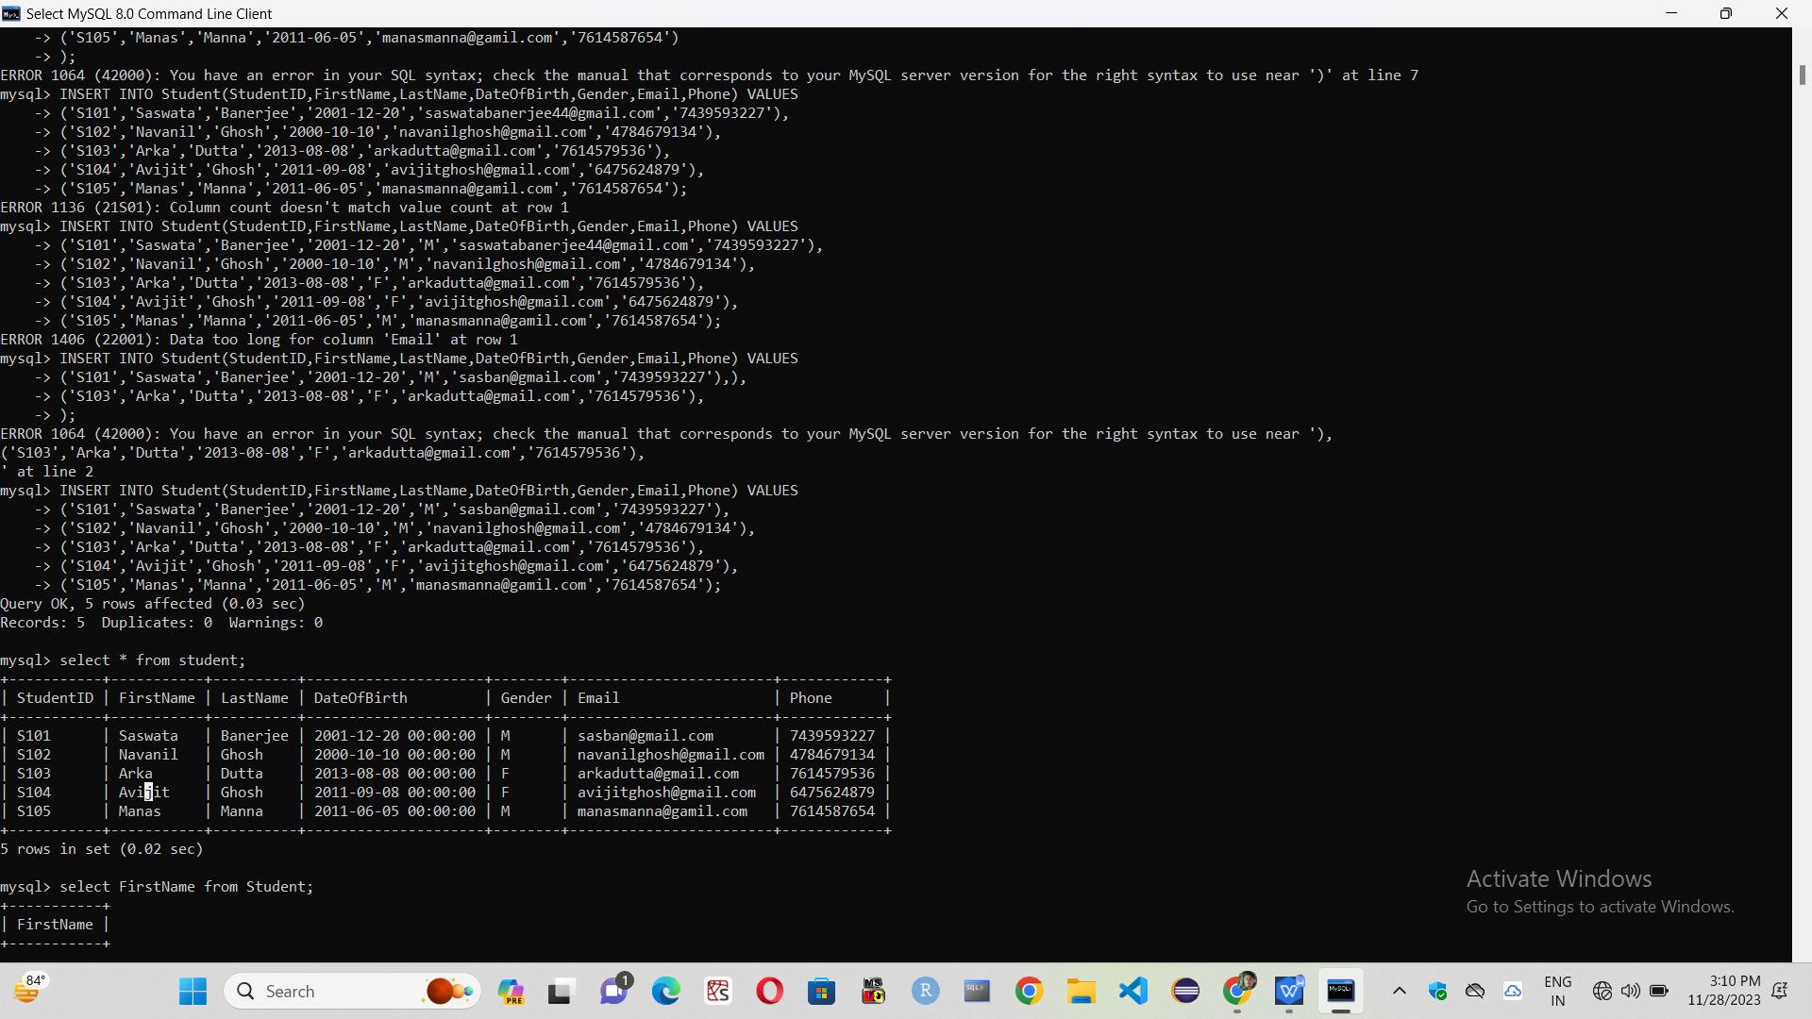

**c.**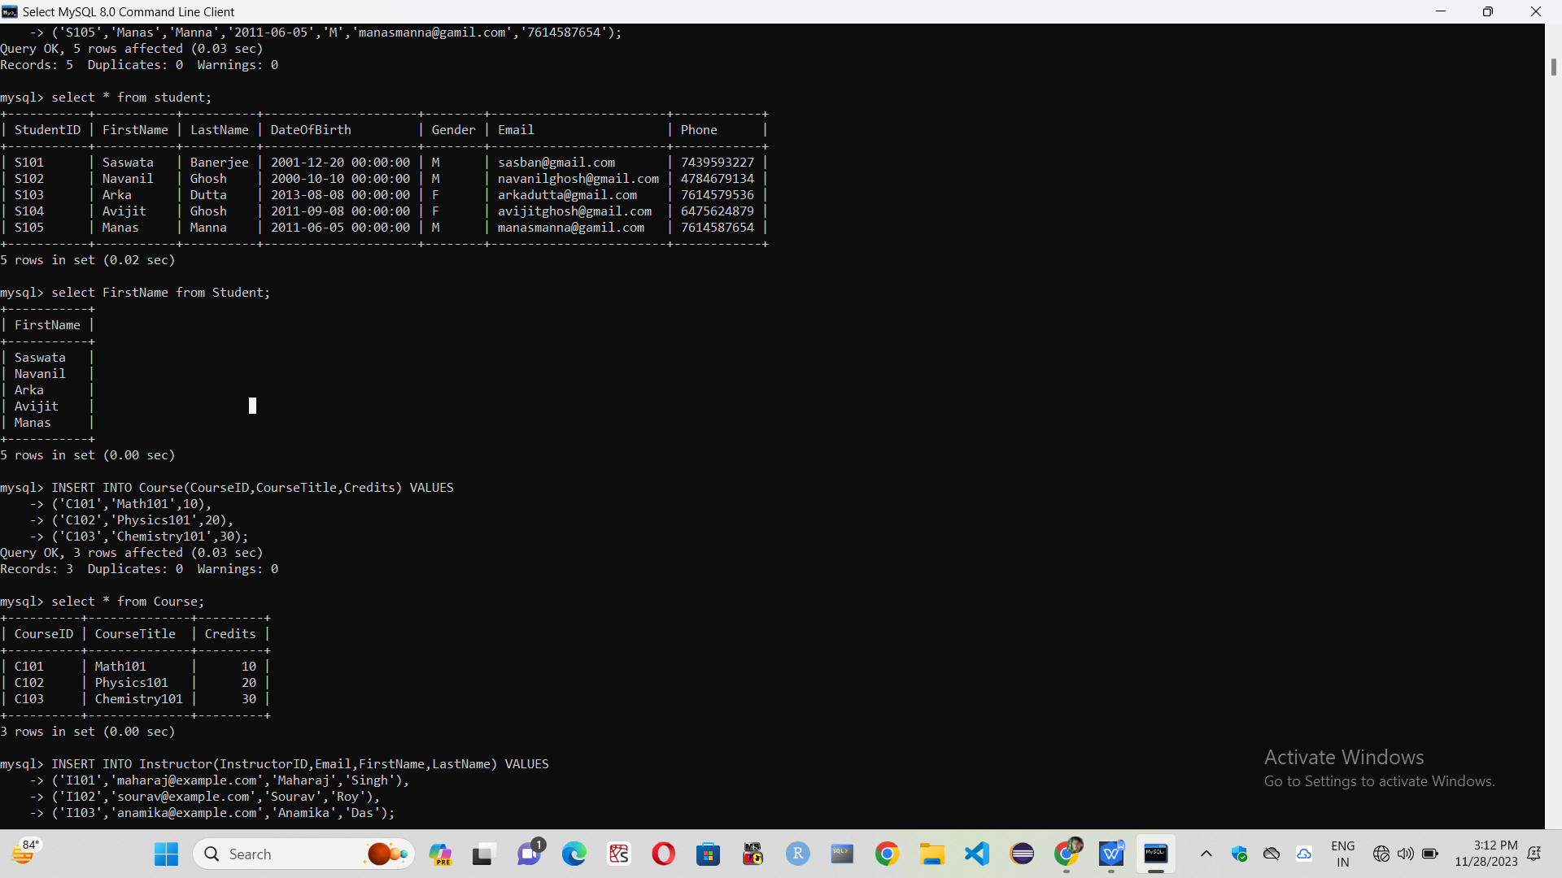

**2.a.Insert records in Course table-->**

INSERT INTO Course(CourseID,CourseTitle,Credits) VALUES

-> ('C101','Math101',10),

-> ('C102','Physics101',20),

-> ('C103','Chemistry101',30);

**b.Retrieve data from Course Table-->**

select * from Course;

**Output:-**

**a.**

Query OK, 3 rows affected (0.03 sec)

Records: 3 Duplicates: 0 Warnings: 0

**b.**

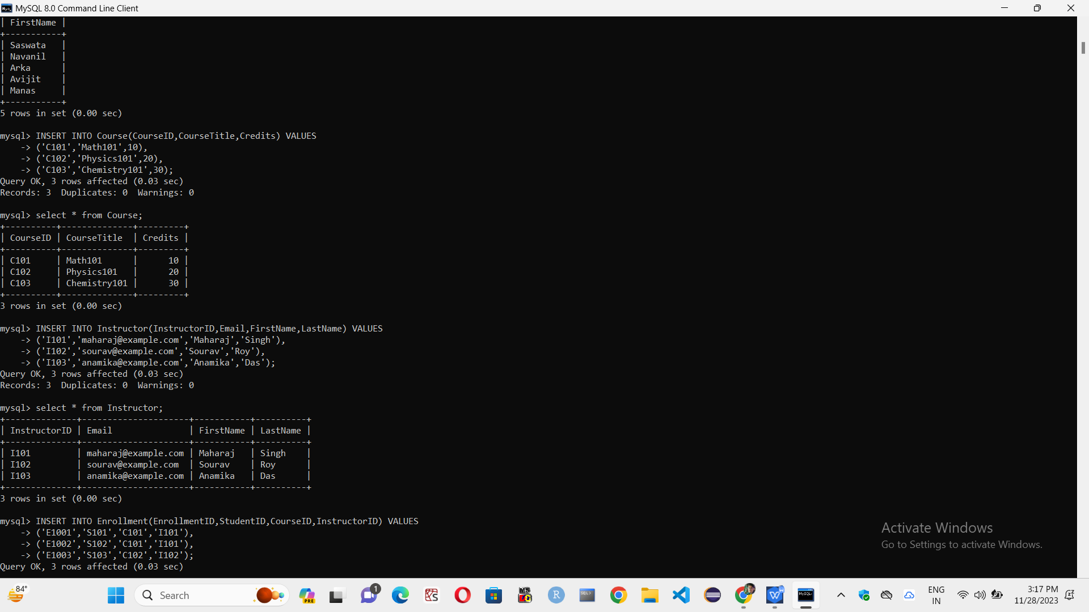

**3.a.Insert records of Instructor table-->**

INSERT INTO Instructor(InstructorID,Email,FirstName,LastName) VALUES

-> ('I101','maharaj@example.com','Maharaj','Singh'),

-> ('I102','sourav@example.com','Sourav','Roy'),

-> ('I103','anamika@example.com','Anamika','Das');

**b.Retrieve data from Instructor table-->**

select * from Instructor;

**Output:-**

**a.**

Query OK, 3 rows affected (0.03 sec)

Records: 3 Duplicates: 0 Warnings: 0

**b.**

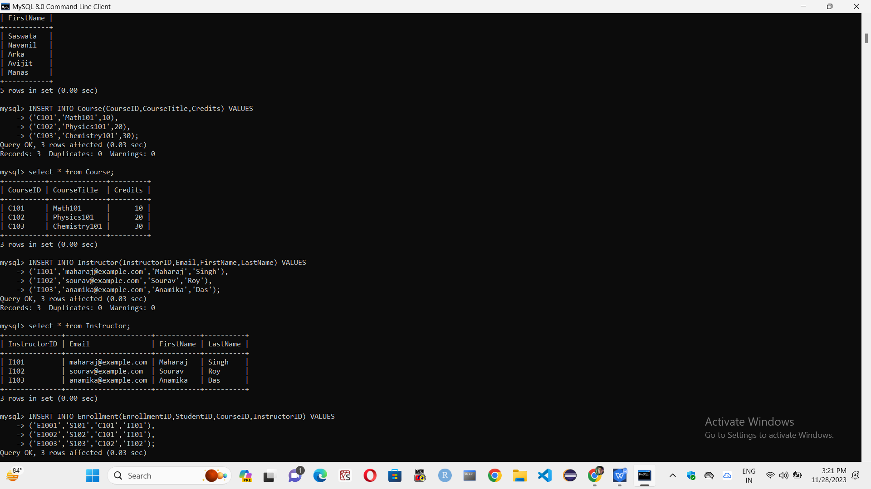

1. **a. Insert records of Enrollment table-->**

INSERT INTO Enrollment(EnrollmentID,StudentID,CourseID,InstructorID) VALUES

-> ('E1001','S101','C101','I101'),

-> ('E1002','S102','C101','I101'),

-> ('E1003','S103','C102','I102');

**b.Retrieve data from Enrollment table-->**

select * from Enrollment;

**Output:-**

**a.**

Query OK, 3 rows affected (0.03 sec)

Records: 3 Duplicates: 0 Warnings: 0

**b.**

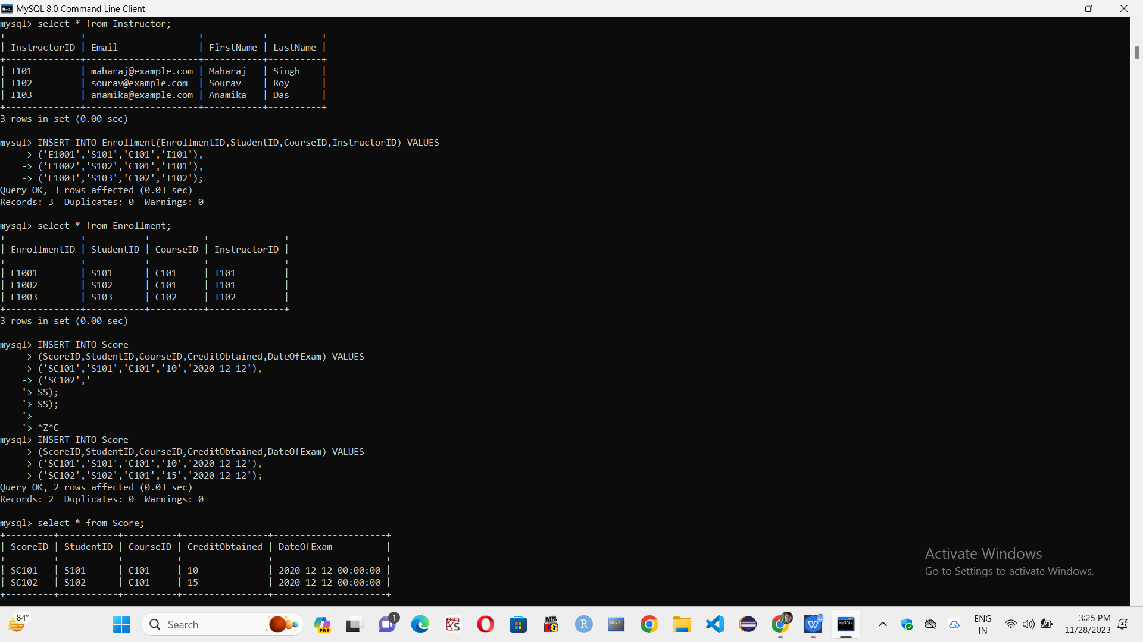

1. **a.Insert records of Score table-->**

INSERT INTO Score

-> (ScoreID,StudentID,CourseID,CreditObtained,DateOfExam) VALUES

-> ('SC101','S101','C101','10','2020-12-12'),

-> ('SC102','S102','C101','15','2020-12-12');

**b.Retrieve data from Score table-->**

select * from Score ;

**Output:-**

**a.**

Query OK, 2 rows affected (0.03 sec)

Records: 2 Duplicates: 0 Warnings: 0

**b.**

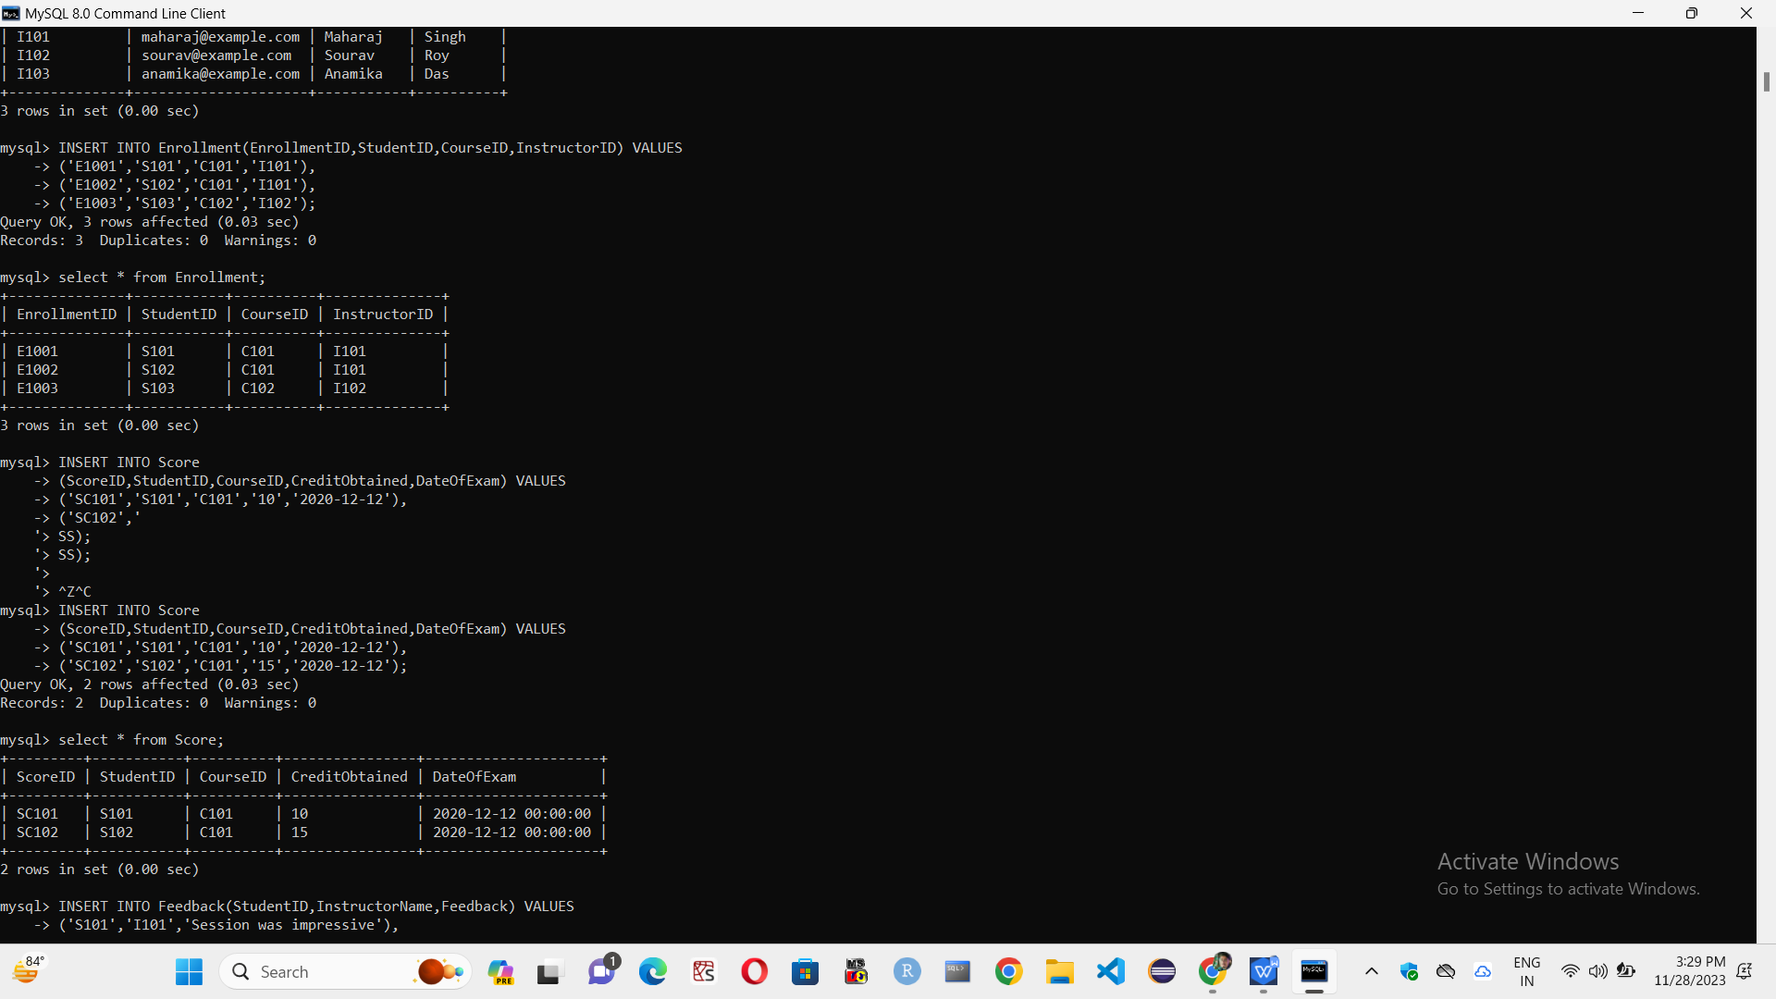

1. **a.Insert records of Feedback table-->**

INSERT INTO Feedback(StudentID,InstructorName,Feedback) VALUES

-> ('S101','I101','Session was impressive'),

-> ('S102','I101','Topic was well varge and good explained'),

-> ('S103','I102','Session was super');

**b.Retrieve data from Feedback table-->**

select * from Feedback;

**Output:-**

**a.**

Query OK, 3 rows affected (0.03 sec)

Records: 3 Duplicates: 0 Warnings: 0

**b.**

